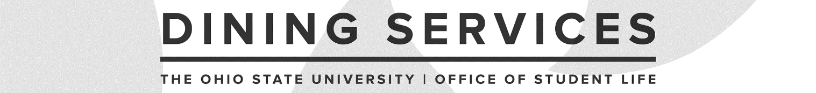

Dining Utility Worker Interview Guide
Updated May 2021

Candidate: __________________________________________ Date: ______________

Interviewer: _________________________________________ Operation: ______________

Introduction
Interview panel should start by introducing themselves (share pronouns, if comfortable) and sharing their title and how they interact with this position. Interview lead should then share the following with the candidate:

We are excited to be speaking with you further about your interest in the Dining Utility Worker role. Today, our questions will focus more holistically on the varying aspects of this position. We have up to 30 minutes for your interview today. You are welcome to ask us to repeat any question and there will be time at the end for you to ask any questions. We will be taking notes as you talk, so pardon our pauses as we go through the interview.

Interview Questions

Initiative
- Our department’s mission is to provide authentic service and extraordinary food. Please provide us an example of a time you did something extraordinary for a customer.
- Tell us about a time when your workload was light, and you had to find work to do on your own.

Technical Learning/Skills
- Describe a situation that required you to learn new technical knowledge and skills. How did you go about learning it and how much time did you commit to it?
Communication & Teamwork
- Describe specific actions you take to promote a cooperative team environment among your peers.
- Describe a time when you had to help resolve a tense situation in the workplace.
Customer Service
- Please describe a time you experienced extraordinary customer service.
Time Management/Organization
- Through examples, tell us how you keep yourself on task to accomplish your workload during a shift.
Operation-Specific
- Add 1-2 questions that are related to your location.

Wellness
- Our Dining Utility Workers can sometimes have a high-volume to tasks to complete during a shift. How do you keep motivated through stressful times?

- Many of our staff members engage in various practices to maintain a sense of well-being; anything from walking to meditation. Please share a method you use to take care of yourself.

Interview Wrap-Up

- What questions do you have about this position?

Wrap-Up
- Explain to the candidate next steps in the selection process and timeframe for making a decision.
- Provide candidate with a contact name and e-mail address/phone # for any follow-up questions.
- Thank the candidate for their time.

To be completed by the interviewer(s):

Overall Feedback/Notes:

Recommendation:

____ Recommend for hire
____ Recommend with reservations
____ Do not recommend

